Povezave do naših strani:
Cups market: http://market.pythonanywhere.com/upchillingzone/
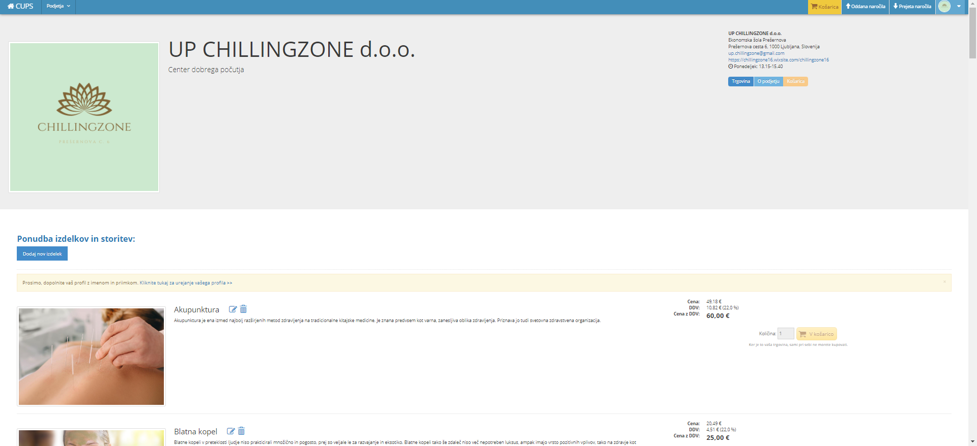

Facebook: https://www.facebook.com/podjetje.chillingzone.1/
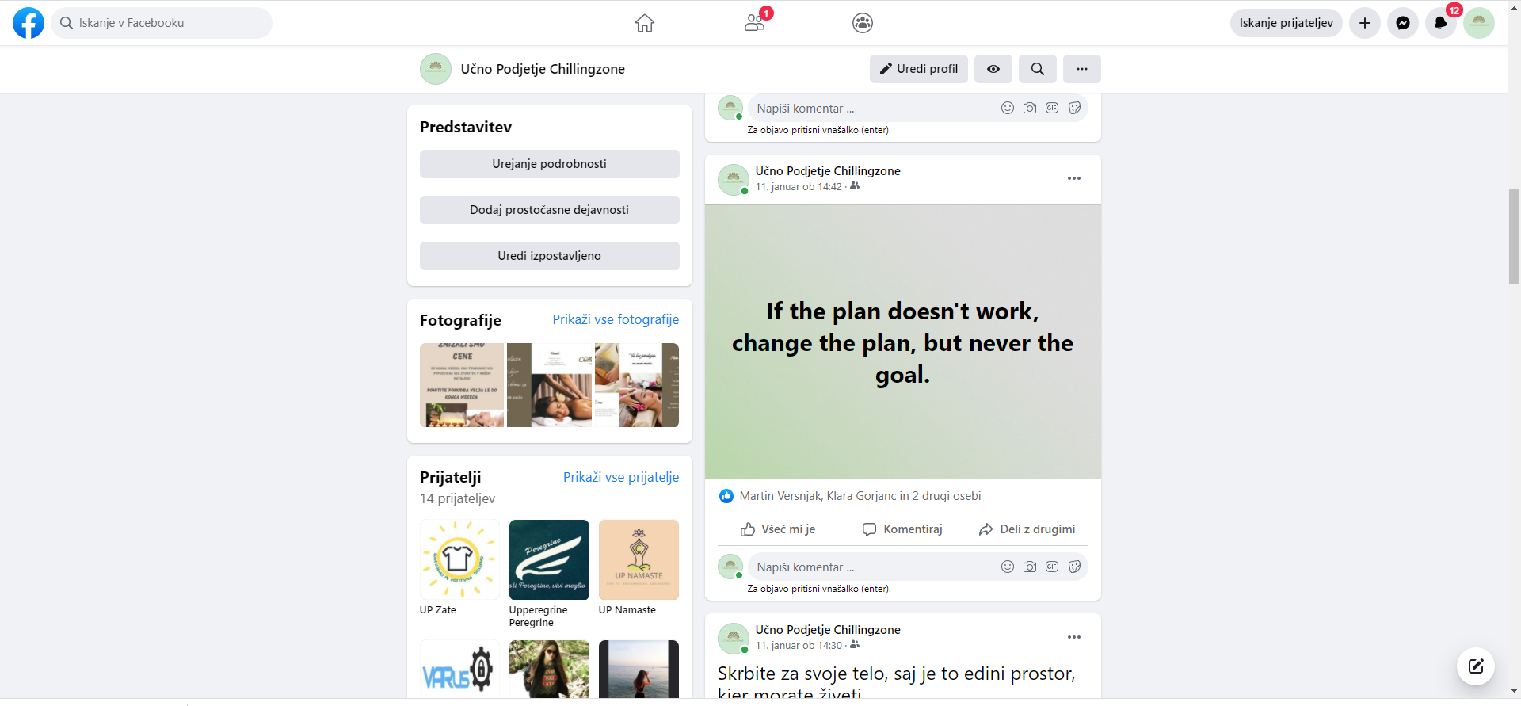

Instagram: https://www.instagram.com/up.chillingzone/

