VIRTUALNE POVEZAVE

CUPS market: http://market.pythonanywhere.com/
Spletna stran: https://betterflysesg.wixsite.com/betterfly
E-mail: better.fly.sesg@gmail.com
Instagram: https://www.instagram.com/up_betterfly/
Facebook: https://www.facebook.com/UP-Better-Fly-106533214565907

Prezzi: 4. virtualna tržnica CUPS
https://prezi.com/i/gzqwonmqx1pp/podjetje/?fbclid=IwAR2OuhDl_AJExV3UubykVaSQOi9Mc5Q0_EW8iRA7JqvSYHtI8lJf6LF0VOE

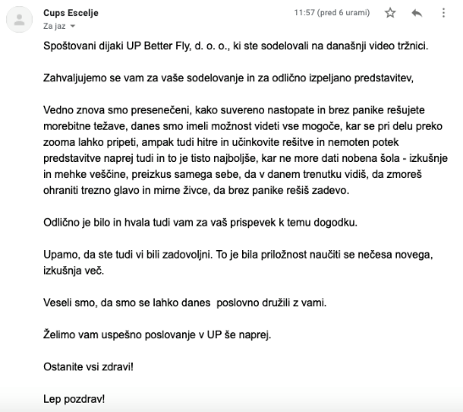

https://www.facebook.com/sesmb/posts/3675408595876281

https://www.facebook.com/sesmb/videos/169501188008974

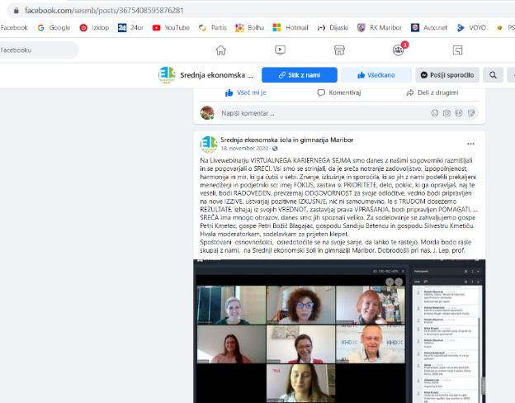
https://www.facebook.com/sesmb/photos/pcb.3512608152156327/3512607978823011/
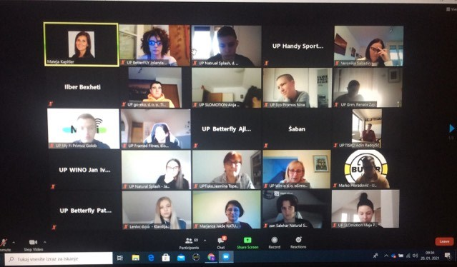

https://www.facebook.com/sesmb/photos/pcb.3509555839128225/3509554359128373/
https://www.facebook.com/sesmb/videos/359124872053546
https://www.facebook.com/sesmb/photos/pcb.3473398646077278/3473397802744029/
https://www.facebook.com/sesmb/photos/pcb.3435276843222792/3435276339889509/

https://www.facebook.com/sesmb/photos/pcb.3416951855055291/3416951311722012/
https://www.facebook.com/sesmb/photos/pcb.3373426906074453/3373426526074491/
https://www.facebook.com/sesmb/photos/pcb.3352383278178816/3352382174845593/
https://www.facebook.com/sesmb/photos/pcb.3330625220354622/3330624347021376/

https://wordwall.net/resource/10021906/kolo-sre%c4%8de-betterfly
