C
O
N
N
E
C
T !

Prijepolje, Sebija 2021.
Student company "USB team" isformed on December 19, 2017 in the Economic and Trade School in Prijepolje, Serbia.
The company's business is based on the production of male and female fashion details and cosmetics.

The goal of the company is to develop the entrepreneurial spirit of students of different educational
profiles, which will acquire new knowledge in the field of marketing, entrepreneurship, rights and
financial operations through business.

U
S
B
TEAM

The purpose of th e company is to bring together a fresh inspiration

PRODUCT NAME | PRICE | THE ARTICLE CODE | ABOUT PRODUCT | PICTURE
Women`s gift  Box | 14,5 (eur) | GB-1 | It consists of our individual women's products, and can be used to surprise a loved one. | 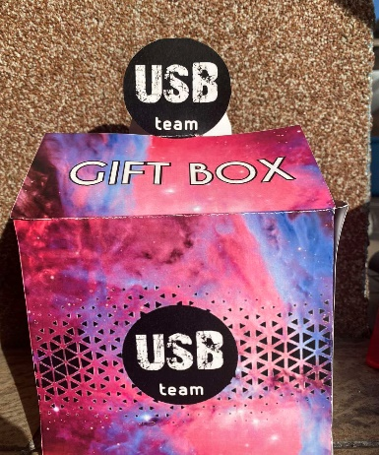
Men`s gift box | 14,5 (eur) | GB - 2 | It consists of our individual men's products that can be used for our other products as well as for gifts for loved ones. | 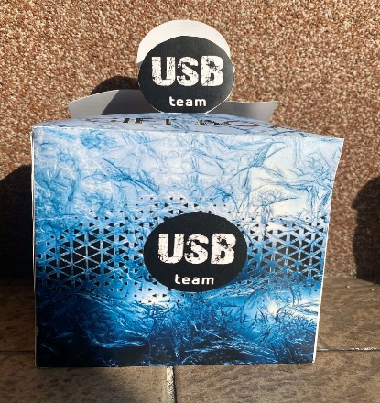

PRODUCT NAME | PRICE | THE ARTICLE CODE | ABOUT PRODUCT | PICTURE
Kasteri | 1,3 (eur) | M-3 | This product contains 25ml. Kosateri is an ideal product that protects from the unpleasant smell of sweat, prevents the formation of stains on your clothes. | 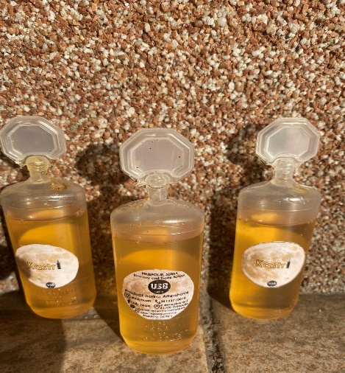
Protective mask | 1,5 (eur) | U-1 | This US product is used for protection against viruses and diseases, as well as against COVID viruses, which is available to all our customers. | 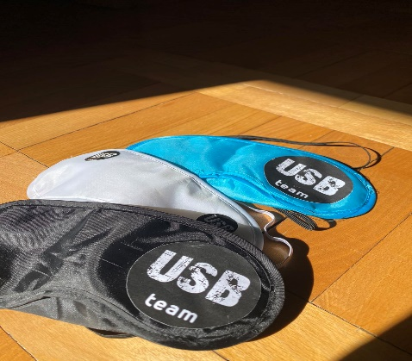

PRODUCT NAME | PRICE | THE ARTICLE CODE | ABOUT PRODUCT | PICTURE
VICTORIA  (bath bomb) | 2,1 (eur) | U-3 | With essential oil with lavender and lemon  This product is used to soften the skin and has a clean and fresh scent. It can be used immediately after bathing or shaving. | 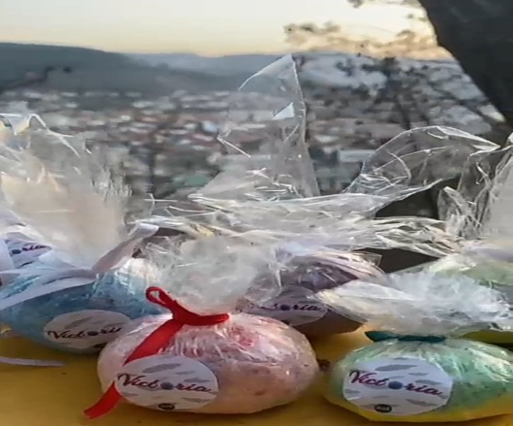
VILNIUS  (women`s necklace) | 2,9 (eur) | W-2 | Handmade from a chain that makes you look perfect. It is handmade and suitable for all ages. | 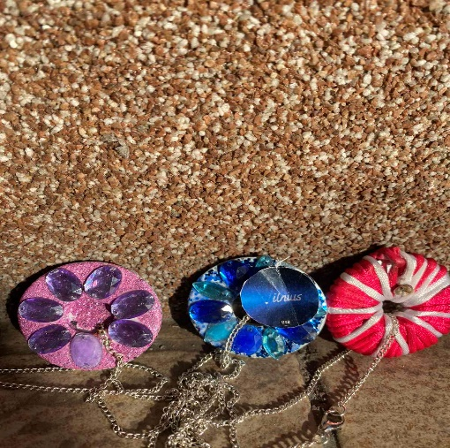

PRODUCT NAME | PRICE | THE ARTICLE CODE | ABOUT PRODUCT | PICTURE
LIMA  (candle) | 1,6 (eur) | W-3 | Different shapes with essential oil, which refreshes the air and gives an exceptional scent. | 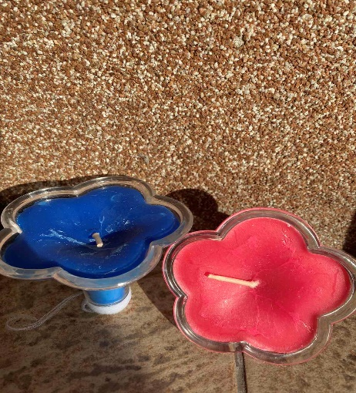
Hand cream USB | 1,8(eur) | W-4 | Although it has a rich texture, it absorbs very quickly and does not leave a greasy, sticky mark on the surface of the skin. The main component of the cream is calendula oil, which is completely natural in origin and helps to suppress redness. | 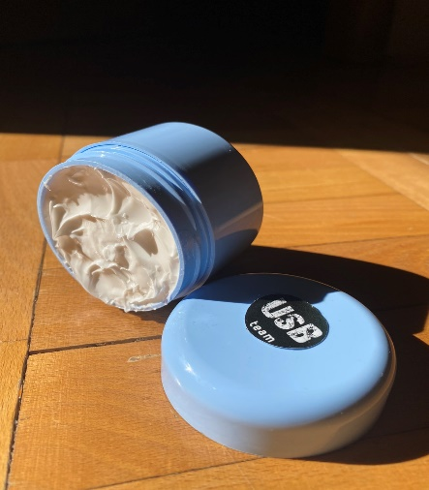

PRODUCT NAME | PRICE | THE ARTICLE CODE | ABOUT PRODUCT | PICTURE
ARGAN SPRAY | W-5 | 2,3(eur) | We present you a hair spray that is completely natural in origin and helps to restore hair. It is applied after washing the hair, and is enriched with argan oil. | 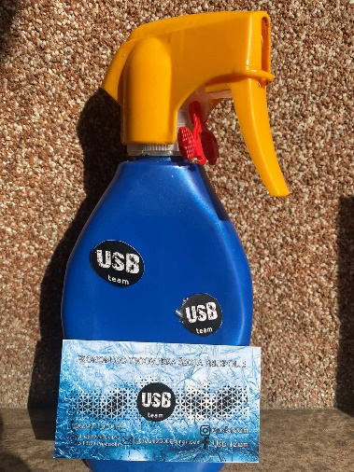
USB SHAMPOO | W-6 | 3,4(eur) | This shampoo is 100% natural. Its most important ingredient is sage root, which renews hair and prevents it from falling out. | 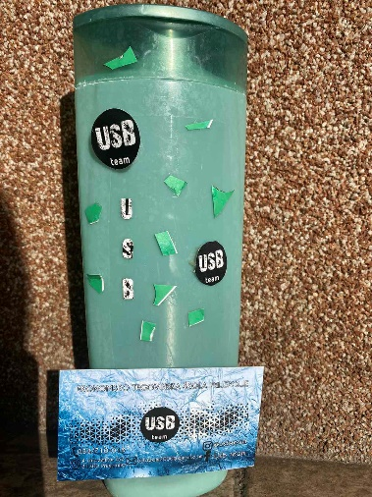

WHERE ARE WE?
We are from Serbia,
The USB TEAM company is located in Prijepolje, In street 4 December br 3
Across the Orsi sports field, Next to the main road E763

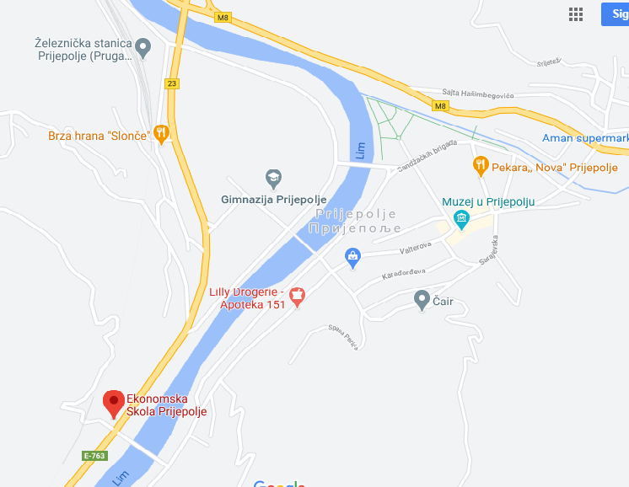
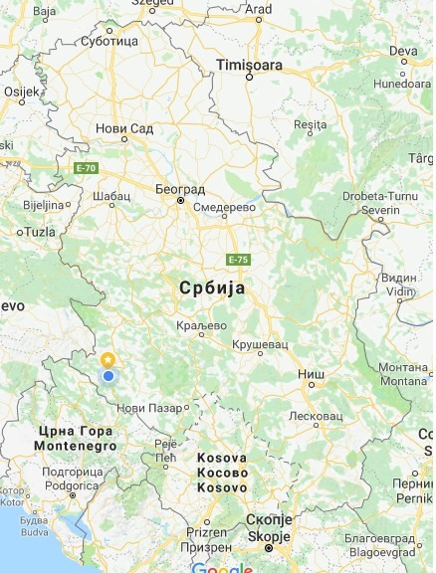

4 december number 3
31300, Prijepolje SERBIA
+38133710018
@ubsteam
Usb team
usbteam2000.wixsite.com/website
usbteam2000@gmal.com

