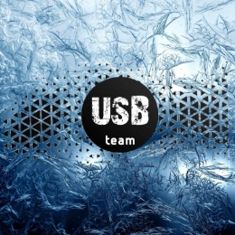
Production and trade of male and female
fashion items and cosmetic products
USB TEAM Ltd
4 december street n. 3., 31300 Prijepolje, Serbia
TIN: 100110165; Bank account CVB:200-0000000001397-00
PE code: RS01242, IBAN: RS67 0010 0000 0150 0057 41
Tel/Fax: +38133710018, E-mail: usbteam2000@gmail.com
CUSTOMER:
Company Name:________________
_____________________________
Аdress: _______________________
Business Accounts:______________

Order No __________

It is only you who want to bring in the desired quantities.
Marks and numbers | Code | Product Name | Measuring unit | Unit Price  (eur) | Quantity
1. | GB-1 | Women’s gift box | item | 14,5
2. | GB-2 | Men’s gift box | item | 14,5
3. | M-3 | Kastri | item | 1,3
4. | U-1 | Protective mask | item | 1,5
5. | U-3 | Victoria | item | 2,1
6. | W-2 | Vilnius | item | 2,9
7. | W-3 | Lima | item | 1,6
8. | W-4 | Hand cream USB | item | 1,8
9. | W-5 | Argan spray | item | 2,3
10. | W-6 | Usb shampoo | item | 3,4

We accept the terms of sale and hope for good business cooperation.
Responsible person:
________________

