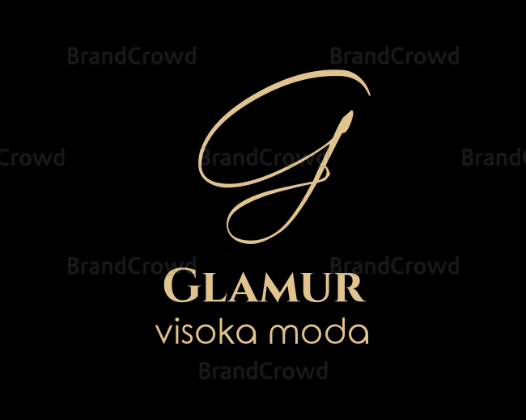
Fall/winter catalog

2020/2021

UP GLAMUR d.o.o.
Ekonomska šola Ljubljana
Prešernova c. 6
1000 Ljubljajna
Slovenija
Tel.: + 386 1 200 67 36
Email : glamur.fashIonlj@gmail.com
We are a learning company that occupy ourselves with sale of chlothing, footware, jewellery and other accessorys of high fashion.
We want to be innovative at original creations and have a variety of diffrent fashion accessorys, that will be wisely selected by our stylists.
We want to be different in fashion consulting and creating new trends for our costumers.
We are starting new trends and unique combination of high fashion.
That is the mission of our company Glamur.
Our products are high quality fashion products, they are made of natural and recycled materials. With this we want to make something good fort he environment. We also use high quality cotton and silk.
Product of high fashion are carefully selected and combined so costumers can get chlothing, footware, jewellery and other accessorys in one place, for a whole fashion look.
We promote the offerings on our website, witch will also include fashion consulting. Our costumers will get special attention when choosing and combining chlothes and other advices for diffrent occasions and practical advices for home. We will regularly inform costumers with the new trends and also promote our offerings.
Mission: With us to the glamourous colection in the closet.

SHOES
Silver high heels
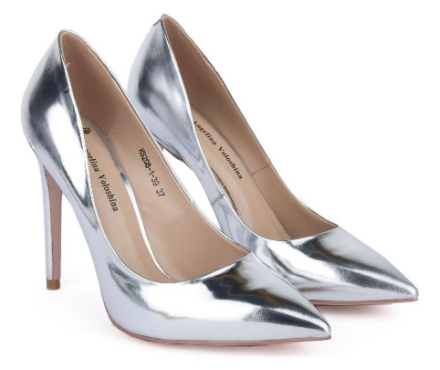
Price: 90,00 €
Tax: 19,80 € (22,0 %)

Price with tax: 109,80 €

Pearly high heels
Price: 92,00 €
Tax: 20,24 € (22,0 %)

Price with tax: 112,24 €

Golden high heels
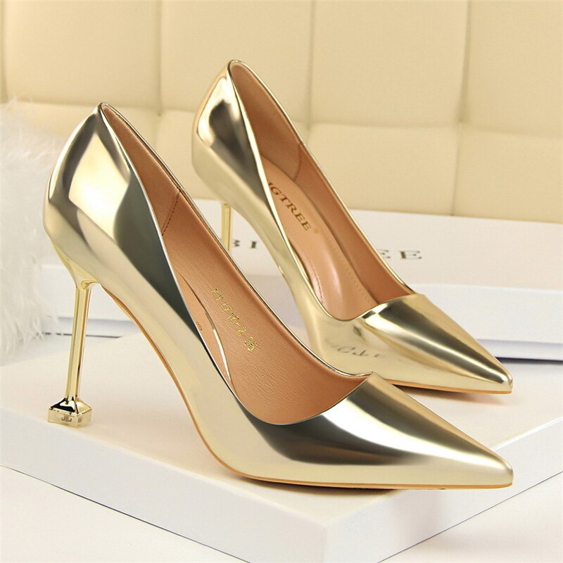
Price: 90,00 €
Tax: 19,80 € (22,0 %)

Price with tax: 109,80 €

Lacy high heels
Price: 89,00 €
Tax: 19,58 € (22,0 %)

Price with tax: 108,58 €

High-heeled boots
Price: 112,00 €
Tax: 24,64 € (22,0 %)

Price with tax: 136,64 €

Mans shoes
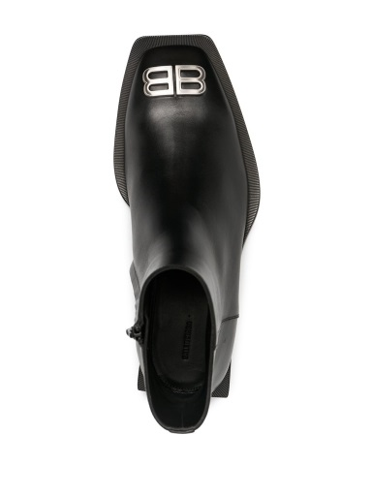
Price: 500,00€

Tax: 110,00€
Price with tax: 610,00€

DRESSES
White dress with lace

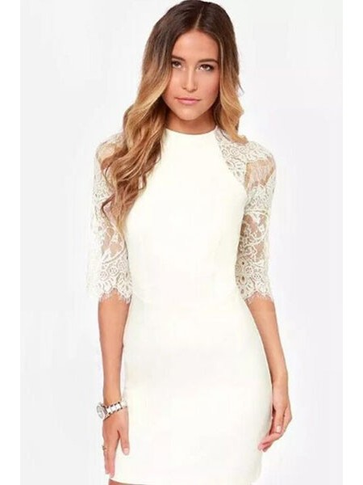

Price: 131,11 €
Tax: 28,84 € (22,0 %)

Price with tax: 159,95 €

White lacy dress with black belt

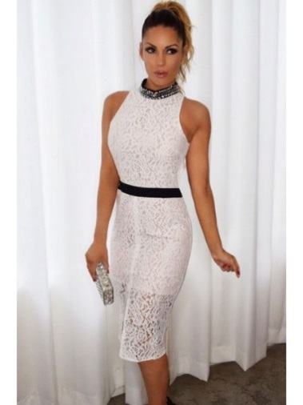
Price: 130,00 €
Tax: 28,60 € (22,0 %)

Price with tax: 158,60 €
Long black dress
Price: 98, 00 €
Tax: 21, 56 € (22, 0 %)

Price with tax: 119, 56 €

Red trouser suit

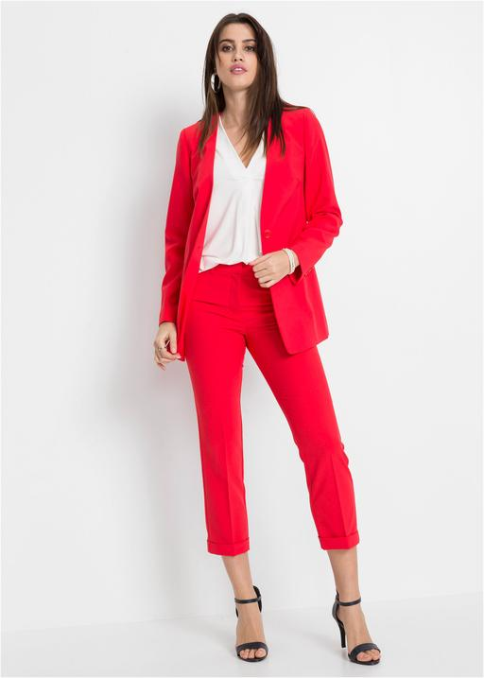
Price: 213, 54 €
Tax: 46, 98 € (22, 0 %)

Price with tax: 260, 52 €

Beige coat

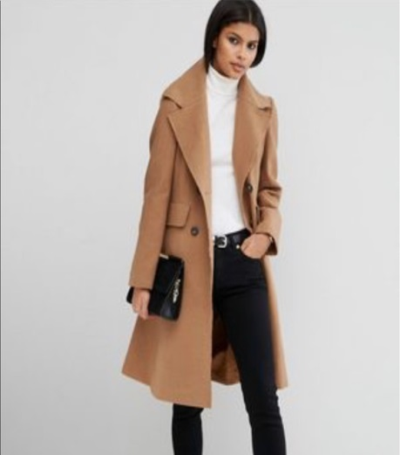

Price: 130,89€
Tax: 28,80€

Price with tax: 159,69€

Fur jacket

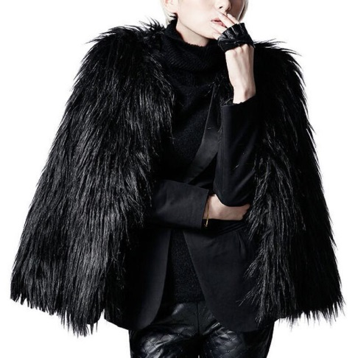

Price: 159,99€
Tax: 35,20€

Price with tax: 195,19€

Versace black jaket
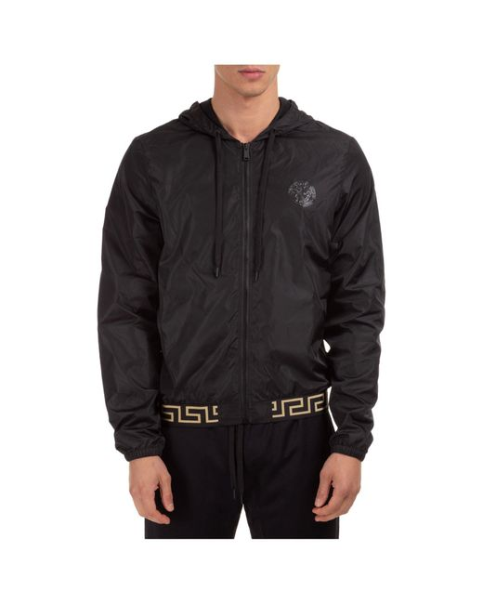
Price: 390,00€
Tax: 85,80€

Price with tax: 475,80€

Leader jacket Kenzo

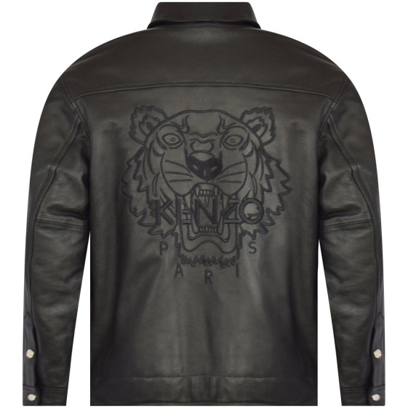
Price: 500,00€
Tax: 110,00€

Price with tax: 610,00€

Man´s outfit in black
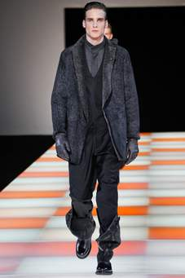
Price: 230,00€
Tax: 50,60€

Price with tax: 280,60€

Man´s outfit in grey

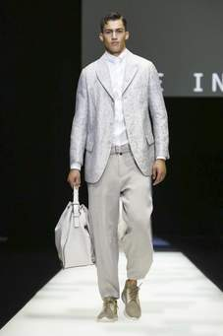
Price: 250,00€
Tax: 55,00€

Price with tax: 305,00€

FASHION ACCESSORIES

Orange bag
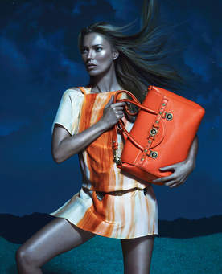

Price: 170, 00 €
Tax: 37, 40 € (22, 0 %)

Price with tax: 207, 40 €

Beige bag
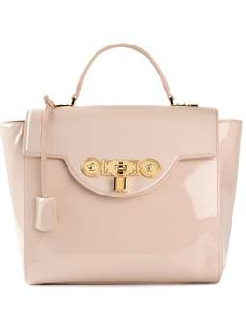
Price: 120, 00 €
Tax: 26, 40 € (22, 0 %)

Price with tax : 146,40 €

Pochette handbag in brown

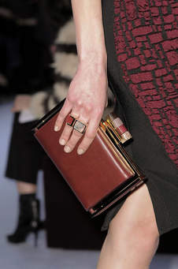

Price: 70,00€
Tax: 15,40€

Price with tax: 85,40€

Pochette handbag in beige

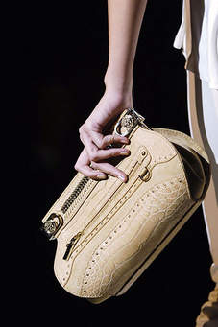

Price: 50,00€
Tax: 11,00€

Price with tax: 61,00€

