CONTENT

Top offers 2
Barcelona 2
Bali 3
Šri Lanka and Maldivi 4
Wellness weekends 5
Terme Čatež 5
Terme Tuhelj 6
Villa Sanja 7
CRUISE 8
Cruising western Mediterranean 8
Cruising mistical Asia 9
Miami and cruising eastern Caribbean 10

Top offers

Barcelona
DATE OF TRAVEL  25.4.  23.5.  15.8. | 1. DAY: BARCELONA  Arrival to Barcelona, city tour, dinner, overnight at the hotel.
TRAVEL PRICE PER PERSON:  23.5.  FIRST MINUTE TRAVEL PRICE: 220,00 €  + Air taxes and fees  REGULAR TRAVEL PRICE: 435,00 €  + Air taxes and fees | 2. DAY: BARCELONA  Breakfast, sightseeing of the oldest part of the city and sights, the play "Magic Fountains", overnight.
25.4., 15.8.  FIRST MINUTE TRAVEL PRICE: 235,00 €  + Air taxes and fees  REGULAR TRAVEL PRICE: 450,00 €  + Air taxes and fees: | 3. DAY: BARCELONA  Breakfast, you will be visited by Park Güell, Sagrada Familia church, FCB Barcelona stadium, hotel dinner, overnight .
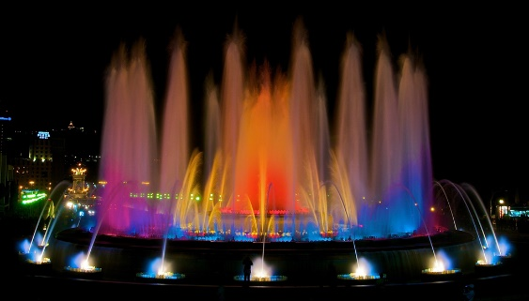 | 4. DAY: EXCURSION MONTSERAT – BARCELONA – ZAGREB  Breakfast and check-out, trip to Montserat, return to Barcelona, leisure, transfer to the airport, return to Zagreb.
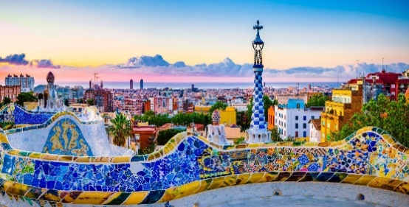
DATE OF TRAVEL:  25.3.-2.4.  30.4.-7.5.  20.-28.6.  3.-11.10.  Minimum of 2 passengers to complete the program! | 5. DAY: BALI/UBUD  Breakfast, day off, overnight at the hotel.  6. DAY: BALI/UBUD/NUSA DUA  Breakfast, check-out, departure to hotel in Nusa Dui, day off, overnight at the hotel.
TRAVEL PRICE PER PERSON:  SPECIAL OFFER FOR PAYMENTS UP TO 30.4.: 500,00 €  FIRST MINUTE: 600,00 €  REGULAR PRICE: 837,50 €  Compulsory supplement for airline fees: HRK 2,990.00 HRK | 7. DAY: BALI/MOUNT AGUNG/BESAKIH/BUKIT JAMBUL/PENGLIPURAN/KERTA GOSA/NUSA DUA  Breakfast, excursion to the eastern part of the Mount Agung Island-Mountains, visit Bukit Jambul, short lunch break, visit to the Palace of Justice named "Kerta Gosa" in Klungkung, return to hotel, overnight.
1. DAY: ZAGREB – DUBAI  Flight Zagreb-Dubai  2. DAY: DUBAI-BALI/UBUD  Continue flight to Denpasar, hotel accommodation, overnight.  3. DAY: BALI/UBUD  Breakfast, yoga, day off, overnight. | 8. DAY: BALI/BATUBULA/CELUK/NUSA DUA  Breakfast, free before noon, excursion, return to hotel, overnight.  9. DAY: BALI/NUSA DUA/DENPASAR-DUBAI  Breakfast. day off, evening transfer to the airport, flight to Doha
4. DAY: BALI/UBUD/KINTAMANI/MOUNT BATUR/TAMPAKSIRING  Breakfast, excursion, return to hotel, overnight. | 10. DAY: DUBAI-ZAGREB  Flight to Dubai, Flight Dubai-Zagreb

Bali

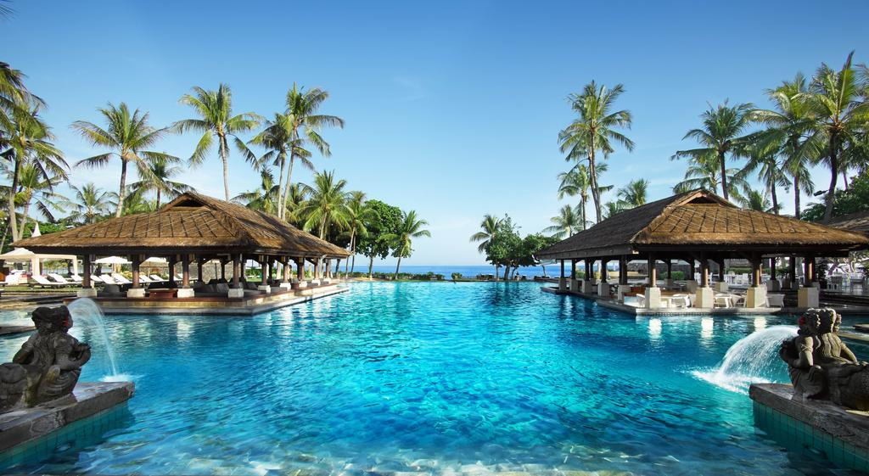
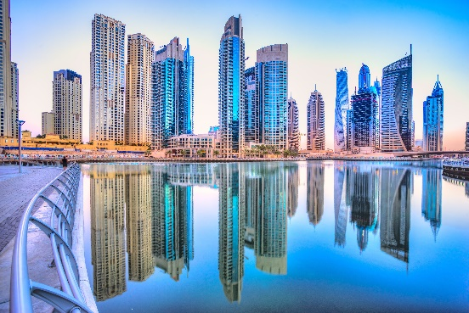

Šri Lanka and Maldivi
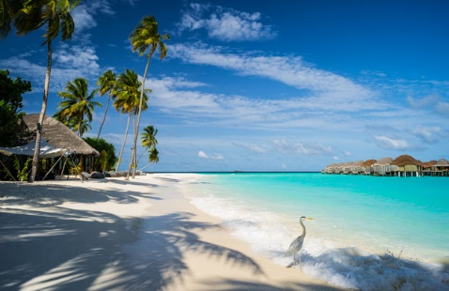
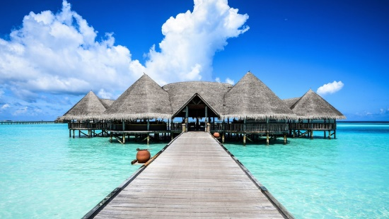

DATE OF TRAVEL:  30.9.-8.10.  9 DAYS/6 NIGHTS | 4.DAY: PASIKUDAH / PINNAWALA – KANDY – PERADENIYA (FAKULTATIVNI IZLET)  Breakfast, all-day excursion starts Pinnawal, continued journey to Peradeniya, return to hotel in the evening, dinner, overnight.
TRAVEL PRICE PER PERSON:  SPECIAL OFFER FOR PAYMENTS UP TO 31.3.: 1.250,00  FIRST MINUTE: 1.300,00 €  REGULAR PRICE: 1.437.50 €  TRAVEL TIME 30.9.-8.10.  Compulsory supplement for airline fees and charges : 3.390,00 HRK | 5. DAY: PANADURA – MALE/MALDIVI  Breakfast available at noon, check-out, flight tp Male, check-in, overnight.  6. DAY: MALDIVI  Breakfast, day off, dinner at the hotel, overnight.
1. DAY: ZAGREB – DOHA  Flight Zagreb-Doha  2. DAY: DOHA – COLOMBO – PASIKUDAH  Continue Doha-Colombo flight, check-in and hotel accommodation, free rest of the day, dinner, overnight. | 7. DAY: MALDIVI  Breakfast, day off, dinner at the hotel, overnight.  8. DAY: MALDIVI – DOHA  Breakfast, check-out, flight to Doha
3. DAY: PASIKUDAH / YALA  Breakfast, jeep safari at Yala Park. evening return to hotel, dinner, overnight. | 9. DAY: DOHA – ZAGREB  Flight to Zagreb continues.

Wellness weekends

Terme Čatež

The Čatež Terme is a place of rest and fun, as it offers healthy water fun and relaxation effects of hot thermal water in summer and winter. Čatež Terme is ideal for family trips and many sports activities.
Experience an exciting family vacation!
Hotel Mjehurić 3*
Price for two persons in double room:
Package “TIME FOR FAMILY”: 210,00 €

Hotel Mjehurić 4*
Price for two persons in double room:
Package “WINTER MAGIC”: 215,00 €
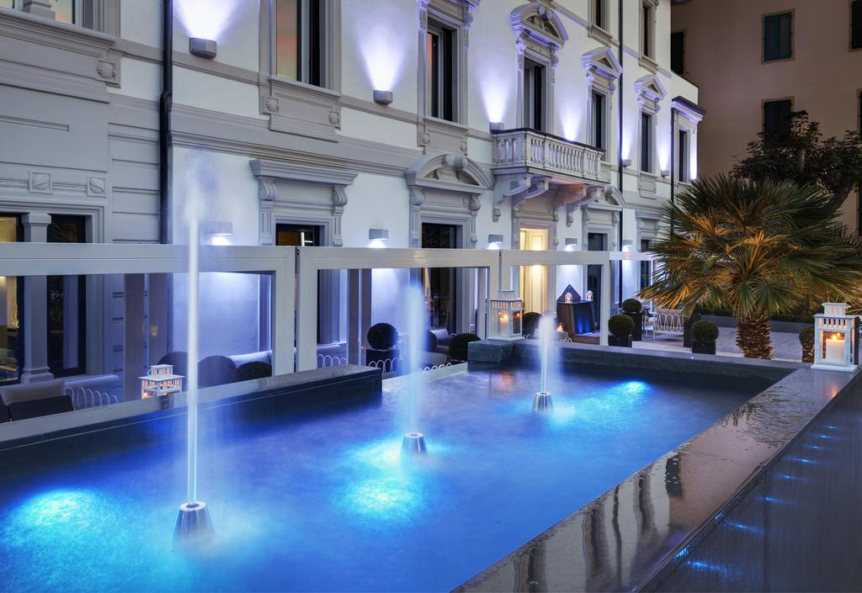

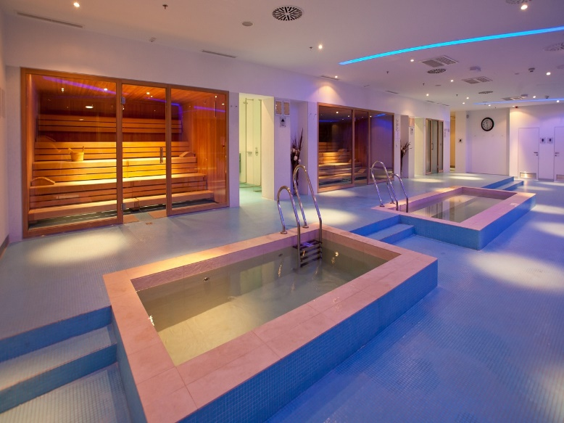

Terme Tuhelj

The modernly equipped Hotel Adriatic offers a diverse range of wellness programs.
We are located near the capital Zagreb, which is why we are an ideal venue for seminars and conferences, and the modern convention center is located in the hotel.
Premium room: in the new part of Adriatic Hotel: shower / bath, hairdryer, telephone, mini bar, TV, safe, balcony
Classic Room: in the new part of Adriatic Hotel: shower / bath, hairdryer, telephone, TV, mini bar, balcony in most rooms.Price highlighted at: www.adriatic.center

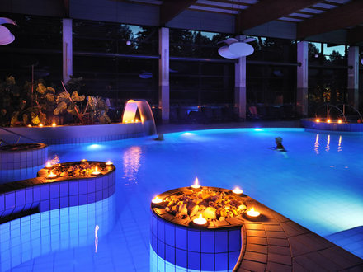

Villa Sanja

Thinking of a relaxing weekend and a romantic atmosphere? Visit Villa Sanja and relax with wellness and massages with expert masseurs and chiropractors.
Price per person (3 days, 2 nights): 462,50 €
THE ARRANGEMENT INCLUDES:
accommodation in a luxuriously equipped Spa with Jacuzzi and thermal water and a terrace with panoramic views of the surroundings
1, 2 or 3 x breakfast served in the room
1, 2 or 3x exclusive 5-course dinner
bottle of wine or bottle of champagne on arrival (on request)
unlimited use of panoramic wellness & spa oasis (heated indoor swimming pool, with thermal water, Finnish sauna, combined bio and infra sauna, Turkish sauna, relax zone with heated bench, outdoor pool during summer months, sun terrace)
unlimited use of fitness: treadmill, bicycle, multifunctional exercise equipment
1 x 30 min relax massage with aromatic oils per person
50 kn per person gift voucher for additional massages or treatments
bathrobes, slippers, towels.
More information at: www.adriatic.center
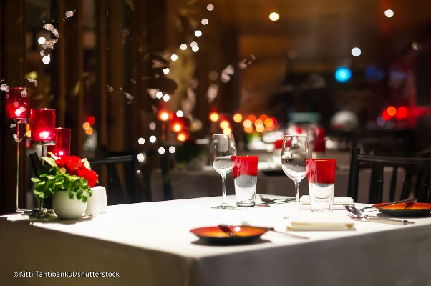

CRUISE

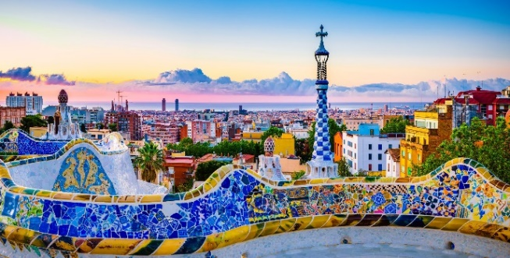
Cruising western
Mediterranean

DATE OF TRAVEL:  18.5. – 26.5.  * When booking a cruise, surcharges for airline and port fees – 430,00 € per person.  DOCUMENTS REQUIRED FOR TRAVEL: Passport must be valid for a minimum of 6 months from the date of departure. | 3. DAY: Palma de Mallorca, Španjolska  4. DAY: Marseille, Francuska  5. DAY: La Spezia (Firenze, Pisa), Italia  6. DAY: Civitavecchia (Rim), Italija  7. DAY: Napulj, Italija
Arrangement price per person  Inside cabin: 1.812,50 €  Window cabin, sea view: 1.900,00 €  Balcony cabin, sea view: 2.250,00 € | 8. DAY: Plovidba  9. DAY: Barcelona-Zagreb  Barcelona - Disembark  Free time for your own activities until transfer to the airport.  Flight-Barcelona-Zagreb
1. DAY: Zagreb-Barcelona

Flight Zagreb-Barcelona.
Panoramic tour of Barcelona, hotel accommodation, overnight stay.
2. DAY: Barcelona, Španjolska  Transfer to the port.  Boarding, sailing. | 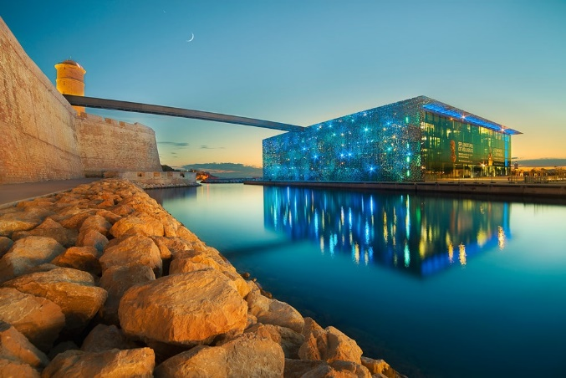
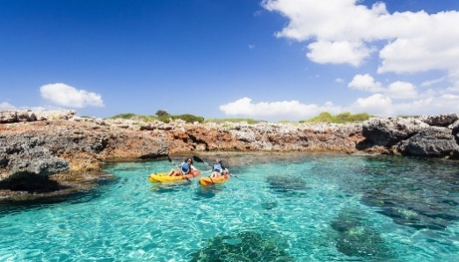

DATE OD TRAVEL:  1.12.-11.12.  Arrangement price per person:  interior cabin classic 2.056,25 €  cabin with classic window 2.150,00 €  cabin with balcony classic 2.400,00 €  Price for children under 18 accompanied by two adults: 1.800,00 €  All prices include port and airline fees, which amount to 690,00 € | 7. DAY: Laem Chabang/Bankok, Tajland  8. DAY: Sihanoukville, Kambodža  9. DAY: Plovidba  10. DAY: Singapur, Singapur  After breakfast aboard, disembark and depart for a half-day sightseeing of Singapore, a night flight to Frankfurt.
1. DAY: ZAGREB-MUNICH-SINGAPUR  Flight Zagreb-Munich, continuation of the flight to Singapore, night flight.  2. DAY: SINGAPUR  Arrival to Singapore, check-in and room accommodation, with travel manager departure to the city by public transport, return to hotel, overnight. | 11. DAY: FRANKFURT-ZAGREB  Arrival to Frankfurt at 6:05 am.  Continue flight to Zagreb.  Anticipated arrival at 2:30 pm.
3. DAY: SINGAPUR  Breakfast, check-out and transfer to the port of embarkation, cabin accommodation and departure. | 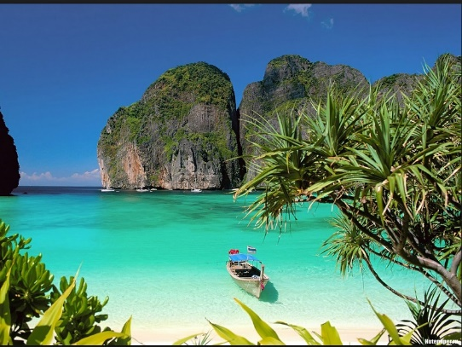
4. DAY: SAILING

5. DAY: KOH SAMUI, TAJLAND

6. DAY: LAEM CHABANG/BANKOK, TAJLAND

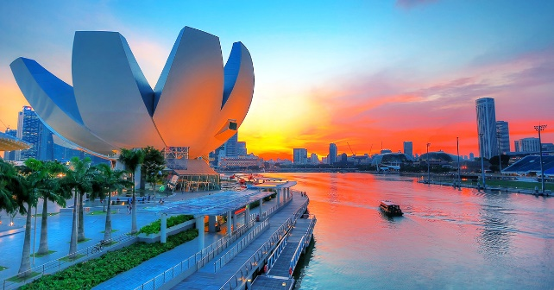
Cruising mistical
Asia

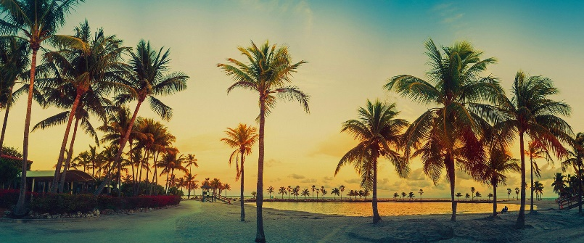
Miami and cruising
eastern Caribbean
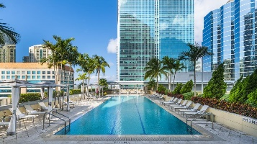

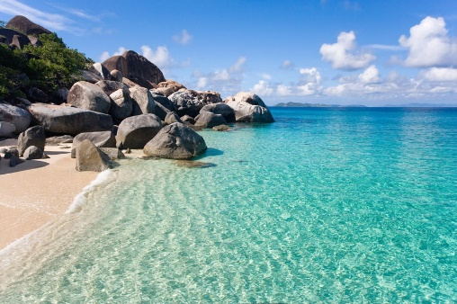
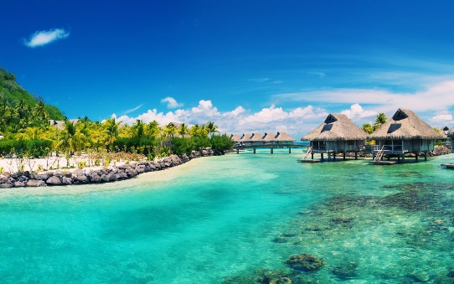
DATE OD TRAVEL:  16.5.-26.5.  Special offer for payments till 28.2. per person: 1.050,00 €  First minute: 1.150,00 €  Regular price: 1.350,00 € | 5. DAY 20.5.: SAILING  Today is scheduled for sailing, overnight on board.  6. DAY 21.5.: ST. THOMAS/US VIRGIN ISLANDS  In the morning after breakfast, about 10am arrival of the boat in St. Thomas, day off, resumption of sailing at 10:00 pm, overnight on board.
1. DAY 16.5.: ZAGREB – PARIZ – MIAMI  Flight Zagreb-Paris, continuation of flight to Miami, check-in and overnight.  2. DAY 17.5.: MIAMI  Breakfast, day off, return to hotel, overnight. | 7. DAY 22.5.: ST. MAARTEN  Wake up today to the beautiful island of St. Maarten, departure at 6:00 pm, overnight on board.  8. I 9. DAY 23. I 24.5.: PLOVIDBA  The next two days are scheduled for sailing, overnight on board.
3. DAY 18.5.: MIAMI-FORTH LAUDERDALE  Breakfast, check-out and transfer to the port, boarding, overnight. | 10. DAY 25.5. FORTH LAURDELDALE -MIAMI -PARIZ  In the morning at 7:00 the arrival of the ship to Fort Lauderdale. Transfer to Miami, free time, flight Miami-Paris
4. DAY 19.5.: BAHAMAS  Wake up in the Bahamas in the morning, day off, overnight on board. | 11. DAN 26.5. PARIZ –ZAGREB  Flight Pariz-Zagreb

