Selska ROAD 119
10 110 Zagreb

PRICE LIST

Ordinal  number | Service | Price without  VAT | VAT amount | Price with VAT
1. | Barcelona | 350,00 | 87,50 | 435,50
2. | Bali | 670,00 | 167,50 | 837,50
3. | Šri lanka and Maldivi | 1.150,00 | 287,50 | 1.437,50
4. | The Western Mediterranean Cruise | 1.450,00 | 362,50 | 1.812,50
5. | Mystic Asia Cruise | 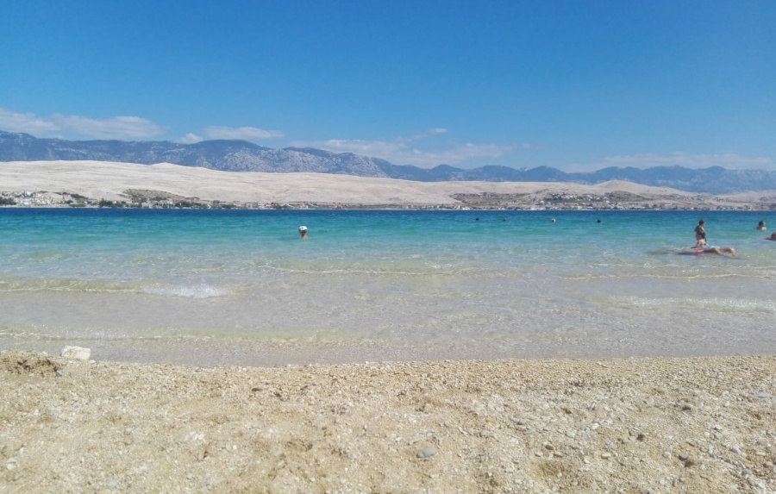  1.645,00 | 411,25 | 2.056,25
6. | Villa Sanja | 370,00 | 92,50 | 462,50

*prices are in euros

